# QUIZ - Causes and lurking variables

## Question 1

Parte superior do formulário

**Below is a graph of Smoking versus FEV from the Causes and Lurking Variables video Part I.**

It comes from data on 654 children from Boston in the 1970s. Among the variables recorded on these children were **Smoking** and **FEV** (Forced Expiratory Volume).

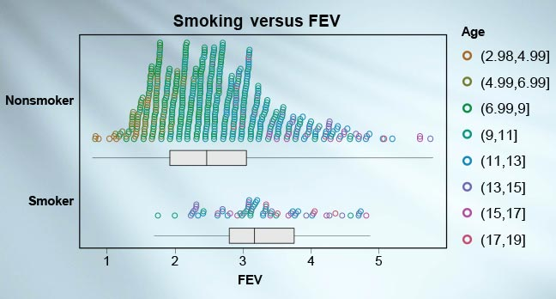

Which of the following statements about this graph are **FALSE**?

The graph shows that the smokers tend to have a larger capacity to blow out air than the non-smokers.

This data came from an observational study.

Age is a confounding variable that affects both **FEV** and likelihood of smoking.

We cannot conclude from this graph that smoking improves lung capacity .

The smoking and non-smoking groups are unbalanced on **Age**because the non-smoking group contains a much greater proportion of younger children than the smoking group.

**The lack of balance that matters most is that the non-smoking group contains a lot more people than the smoking group.**

**Correct**

This answer is **FALSE** – The difference in the number of people in the groups is not the problem. The important imbalance between the groups is that they do not contain people of comparable ages.

Parte inferior do formulário

## Question 2

Parte superior do formulário

**Which one of the following statements is FALSE about experiments and observational studies?**

We cannot reliably conclude causation from an observational study.

**An experiment can be an observational study.**

A randomised experiment is one where we randomly allocate individual units (by chance) to treatment groups.

We cannot reliably make a causal claim from data gathered in a sample survey.

We can most reliably make causal claims when we have a well-designed and executed randomised experiment where we change conditions (or treatments) purposefully.

**Correct**

This statement is **FALSE** – In an experiment, *the experimenter enforces* which experimental units receive the treatment. In an observational study, we simply compare units that *happen to have received* each of the treatments.

Parte inferior do formulário